Artificial Intelligence

Lab 01
Topic | - Setting up IDE (Jupyter Notebook, IPython)  - Python: Variables, Expressions, Operands, Operators
Objective | - Setting up IDE  - What is Jupyter Notebook?  - What is IPython?  - Learning Python  - Variables.  - Expressions.  - Operands.  - Operators.

What is Jupyter Notebook:
Jupyter Notebook is a simplified notebook authoring application, and is a part of Project Jupyter, a large umbrella project centered around the goal of providing tools (and standards) for interactive computing with computational notebooks.
A computational notebook is a shareable document that combines computer code, plain language descriptions, data, rich visualizations like 3D models, charts, graphs and figures, and interactive controls. A notebook, along with an editor like Jupyter Notebook, provides a fast interactive environment for prototyping and explaining code, exploring and visualizing data, and sharing ideas with others.
Jupyter Notebook is a sibling to other notebook authoring applications under the Project Jupyter umbrella, like JupyterLab and Jupyter Desktop. Jupyter Notebook offers a lightweight, simplified experience compared to JupyterLab.

To write a Python program in a Jupyter Notebook, you need to first set up your environment, launch the notebook interface, and then use cells to write and execute your code.

Step 1: Set up Your Environment
Before you can use Jupyter Notebook, you need to have Python installed. The easiest way to get Python, Jupyter, and the necessary data science libraries is by installing Anaconda.
- Download and install the Anaconda distribution for your operating system.
- Alternatively, you can install Jupyter Notebook using the Python package manager pip by running the command pip install jupyter in your terminal or Command Prompt.

Step 2: Launch Jupyter Notebook
Once installed, you can launch the application from your terminal or Anaconda Prompt.
- Open your Terminal (Mac/Linux) or Anaconda Prompt (Windows).
- Navigate to the directory where you want to save your notebooks using the cd command (e.g., cd Desktop).
- Type the command jupyter notebook and press Enter.
- A web browser window should automatically open with the Jupyter Notebook interface.

Step 3: Create a New Notebook
In the browser interface, you can create a new Python notebook file.
- On the main dashboard, click the New button in the top right.
- Select Python 3 (or whichever Python kernel you have installed) from the dropdown menu to open a new notebook in a new tab.
- The new notebook will initially be named Untitled. You can rename it by clicking on the title text at the top of the page and typing a new name.

Step 4: Write and Run Code
Jupyter Notebooks are made up of cells. You can use two primary cell types: Code cells for writing and running Python code, and Markdown cells for writing formatted text and explanations.
- Select a cell by clicking inside it (a green or blue border will appear). New notebooks start with a code cell by default.
- Type your Python code in the cell. For example, type print("Hello World!").
- Run the code in the cell using one of these methods:
- Click the Run button in the toolbar.
- Press Shift + Enter to run the current cell and move to the next one (or insert a new one below).
- Press Ctrl + Enter to run the current cell and stay in place.
The output of your code will appear directly below the cell. You can continue adding new cells (by pressing the + button in the toolbar or B in command mode) to build your program interactively.
Step 5: Save Your Notebook
Jupyter Notebooks are automatically saved periodically, but you can manually save at any time.
- Go to File > Save and Checkpoint.
- The file will be saved with a .ipynb extension in the directory where you launched the server.

Introduction to Python Programming
Python is a general-purpose interpreted, interactive, object-oriented, and high-level programming language. It was created by Guido van Rossum during 1985- 1990.
Prerequisites: You should have a basic understanding of Computer Programming terminologies. A basic understanding of any of the programming languages is a plus.
Python is a high-level, interpreted, interactive and object-oriented scripting language. Python is designed to be highly readable. It uses English keywords frequently where as other languages use punctuation, and it has fewer syntactical constructions than other languages.
• Python is Interpreted − Python is processed at runtime by the interpreter. You do not need to compile your program before executing it. This is similar to PERL and PHP.
• Python is Interactive − You can actually sit at a Python prompt and interact with the interpreter directly to write your programs.
• Python is Object-Oriented − Python supports Object-Oriented style or technique of programming that encapsulates code within objects.
• Python is a Beginner's Language − Python is a great language for the beginner-level programmers and supports the development of a wide range of applications from simple text processing to WWW browsers to games.

History of Python
Python was developed by Guido van Rossum in the late eighties and early nineties at the National Research Institute for Mathematics and Computer Science in the Netherlands.
Python is derived from many other languages, including ABC, Modula-3, C, C++, Algol-68, SmallTalk, and Unix shell and other scripting languages.
Python is now maintained by a core development team at the institute, although Guido van Rossum still holds a vital role in directing its progress.

Python Features
Python's features include –
• Easy-to-learn − Python has few keywords, simple structure, and a clearly defined syntax. This allows the student to pick up the language quickly.
• Easy-to-read − Python code is more clearly defined and visible to the eyes.
• Easy-to-maintain − Python's source code is fairly easy-to-maintain.
• A broad standard library − Python's bulk of the library is very portable and cross-platform compatible on UNIX, Windows, and Macintosh.
• Interactive Mode − Python has support for an interactive mode which allows interactive testing and debugging of snippets of code.
• Portable − Python can run on a wide variety of hardware platforms and has the same interface on all platforms.
• Extendable − You can add low-level modules to the Python interpreter. These modules enable programmers to add to or customize their tools to be more efficient.
• Databases − Python provides interfaces to all major commercial databases.
• GUI Programming − Python supports GUI applications that can be created and ported to many system calls, libraries and windows systems, such as Windows MFC, Macintosh, and the X Window system of Unix.
• Scalable − Python provides a better structure and support for large programs than shell scripting.

Apart from the above-mentioned features, Python has a big list of good features, few are listed below −
• It supports functional and structured programming methods as well as OOP.
• It can be used as a scripting language or can be compiled to byte-code for building large applications.
• It provides very high-level dynamic data types and supports dynamic type checking.
• It supports automatic garbage collection.
• It can be easily integrated with C, C++, COM, ActiveX, CORBA, and Java.

First Python Program:
- Open notepad and type following program
Print (“Hello World”)
2. Save above program with name.py
3. Open command prompt and change path to python program location.
4. Type “python name.py” (without quotes) to run the program.

Variables in Python
A Python variable is a reserved memory location to store values. In other words, a variable in a python program gives data to the computer for processing.
Every value in Python has a datatype. Different data types in Python are Numbers, List, Tuple, Strings, Dictionary, etc. Variables can be declared by any name or even alphabets like a, aa, abc, etc.
Variable Rules:
- Variable name must start with a letter or underscore character.
- Variable name cannot start with a number.
- Variable name can only contain alpha-numeric characters and underscores (A-z, 0-9 and _)
- Variable names are case-sensitive (Name, name and NAME are three different variables)
- Variable name cannot be any of the Python keywords.

How to Declare and use a Variable
Let see an example. We will declare variable "a" and print it.
a=100
print a

Python 1 Example
# Declare a variable and initialize it
f = 0
print (f)
# re-declaring the variable works
f = 'guru99'
print (f)

List of some different variable types
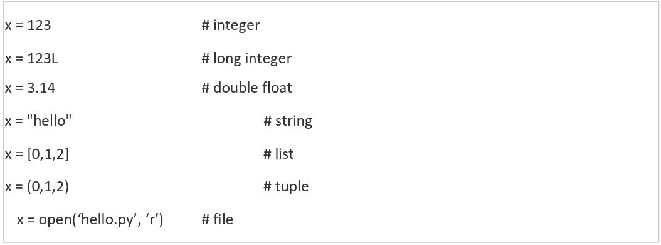

Sample codes:
name = input(“Enter your name: ”)
print(“Hello, ” + name)
Output:
Hello, Asma

num = input(“Enter a number: ”)
print(num)
print(type(num))
Output:
Enter a number: 8
8
<class ‘str’>

num = input(“Enter a number: ”)
print(num)
num=num+2
print(num)
Output:
Error!
-->num=num+2

num = int(input(“Enter a number: ”))
print(num)
num=num+2
print(num)
print(type(num))
Output:
Enter a number: 8
8
10
<class ‘int’>

var = 5
print(var)
Output:
5

1var1 = 5
print(1var1)
Output:
Error!

var 1 = 5
print(var 1)
Output:
Error!

var_var2 = 5
print(var_var2)
Output:
5

a=10
A=20
print(a)
Output:
10

Constants
A constant is a type of variable whose value cannot be changed. It is helpful to think of constants as containers that hold information which cannot be changed later.
Non technically, you can think of constant as a bag to store some books and those books cannot be replaced once place inside the bag.

Assigning value to a constant in Python
In Python, constants are usually declared and assigned on a module. Here, the module means a new file containing variables, functions etc which is imported to main file. Inside the module, constants are written in all capital letters and underscores separating the words.
Example: Declaring and assigning value to a constant
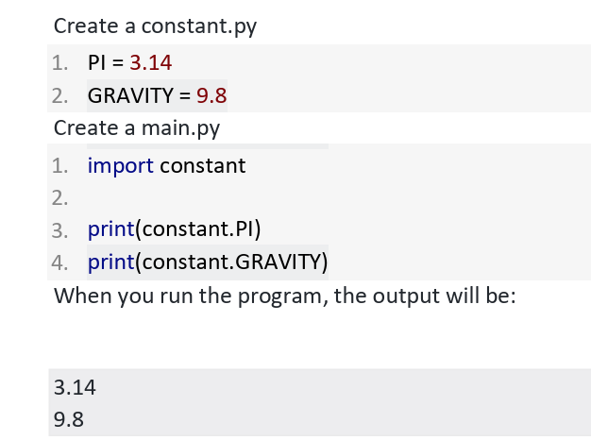

Expressions in Python
In Python, an expression is a combination of values, variables, operators, and function calls that the interpreter evaluates to produce a single result value. Unlike a statement, which performs an action (like assigning a value or creating a loop), an expression always resolves to a specific value or object.
Key Characteristics
- Evaluates to a Value: The core characteristic of any expression is that it yields a result. For example, 2 + 2 evaluates to 4, and len("hello") evaluates to 5.
- Building Blocks: Expressions are the fundamental components used to perform computations and logic in Python programs.
- Can be Simple or Complex: A single literal value (like 42), a variable name (like x), or a complex combination (like a + b * 2 or square(y + 3)) are all considered expressions.
- Used in Statements: Expressions are frequently used within statements. For instance, in an assignment statement like total = price * quantity, the part price * quantity is an expression that is evaluated first, and its result is then assigned to the variable total.

Examples of Expressions:
Type of Expression | Example | Result (when evaluated)
Literal | 10 | 10
Variable | my_variable (if assigned 5) | 5
Arithmetic | (5 + 2) * 3 | 21
String Concatenation | "Hello" + " " + "world!" | "Hello world!"
Comparison (Relational) | 10 > 5 | True
Logical | (x > 10) and (y < 20) | True or False (Boolean result)
Function Call | len("Python") | 6
Conditional (Ternary) | x if x > z else z | The value of x or z, whichever is greater

Operators in Python
Operators are the constructs which can manipulate the value of operands. Consider the expression 4 + 5 = 9. Here, 4 and 5 are called operands and + is called operator.

Types of Operators
Python language supports the following types of operators.
• Arithmetic Operators
• Comparison (Relational) Operators
• Assignment Operators
• Logical Operators
• Bitwise Operators
• Membership Operators
• Identity Operators
Let us have a look on all operators one by one.
Python Arithmetic Operators
Assume variable a holds 10 and variable b holds 20, then –
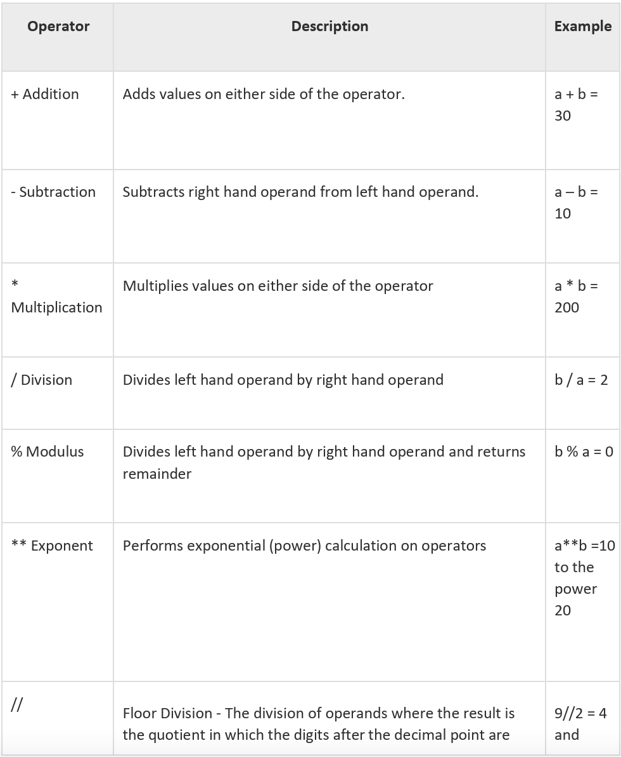
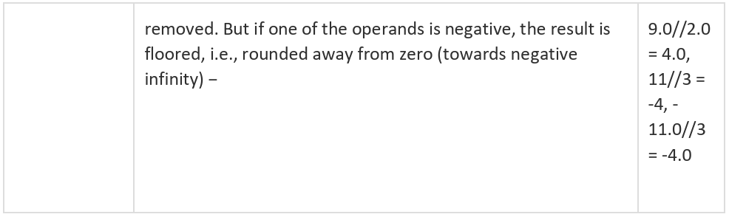

Python Comparison Operators
These operators compare the values on either sides of them and decide the relation among them. They are also called Relational operators.
Assume variable a holds 10 and variable b holds 20, then –
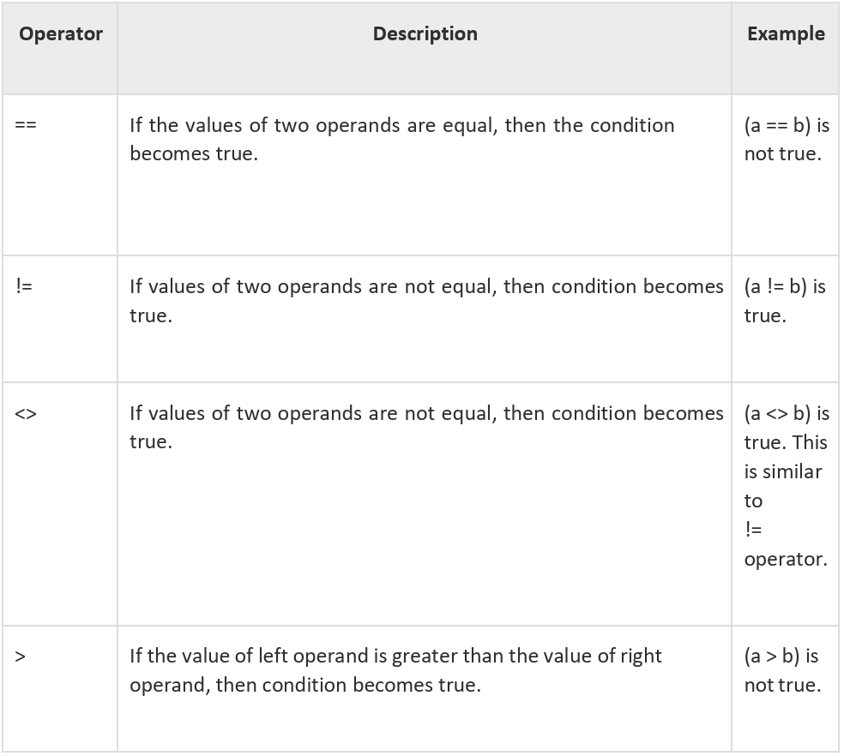
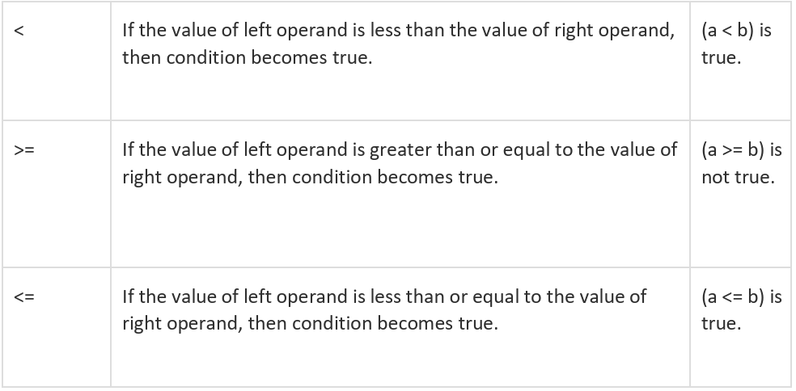

Python Assignment Operators
Assume variable a holds 10 and variable b holds 20, then −
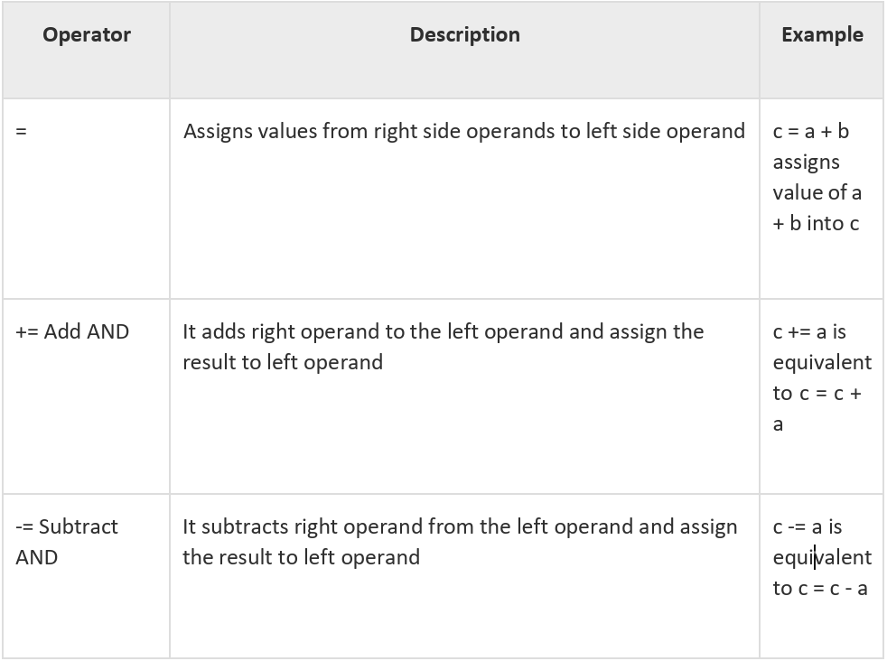
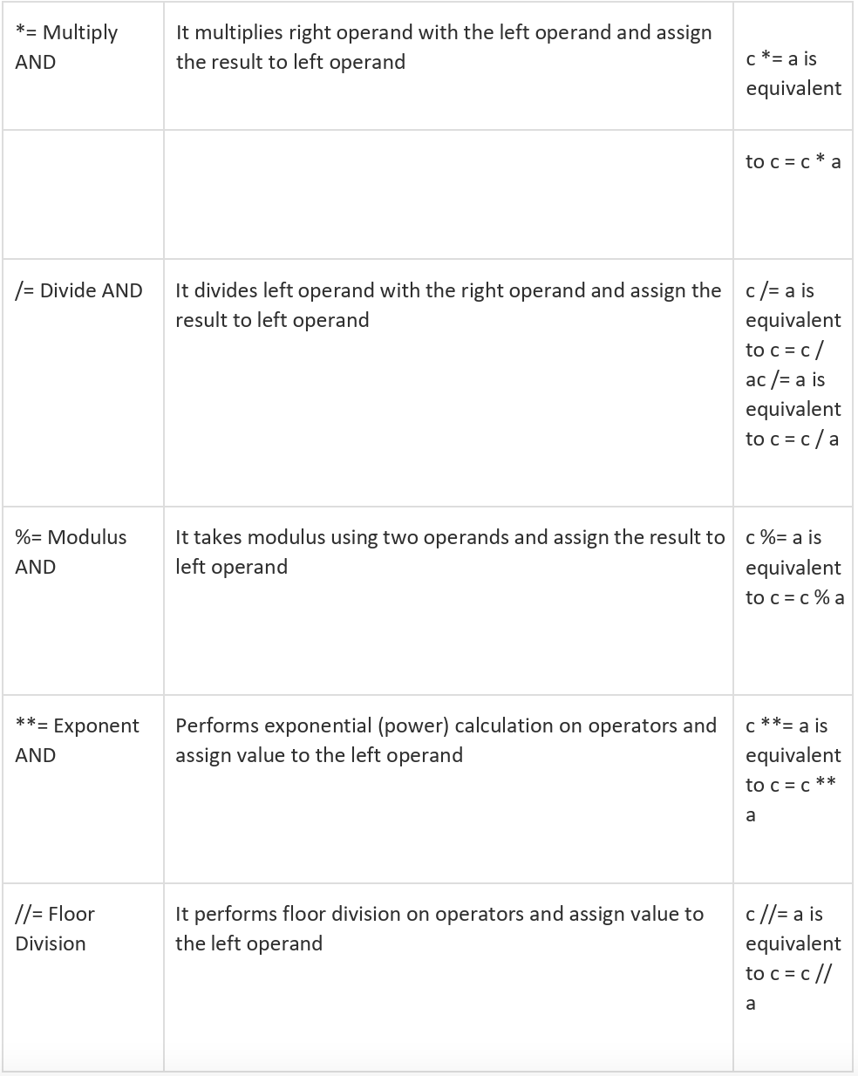

Python Bitwise Operators
Bitwise operator works on bits and performs bit by bit operation. Assume if a = 60; and b = 13; Now in binary format they will be as follows −
a = 0011 1100 b = 0000 1101
a&b = 0000 1100
a|b = 0011 1101
a^b = 0011 0001
~a = 1100 0011

There are following Bitwise operators supported by Python language
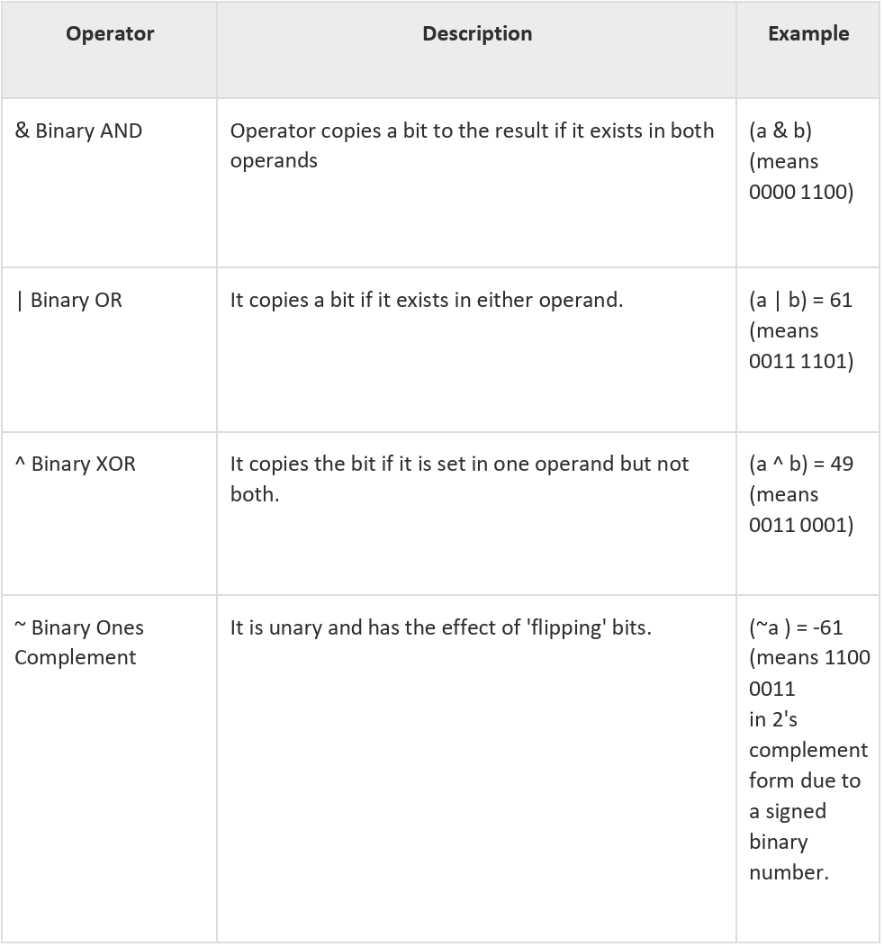
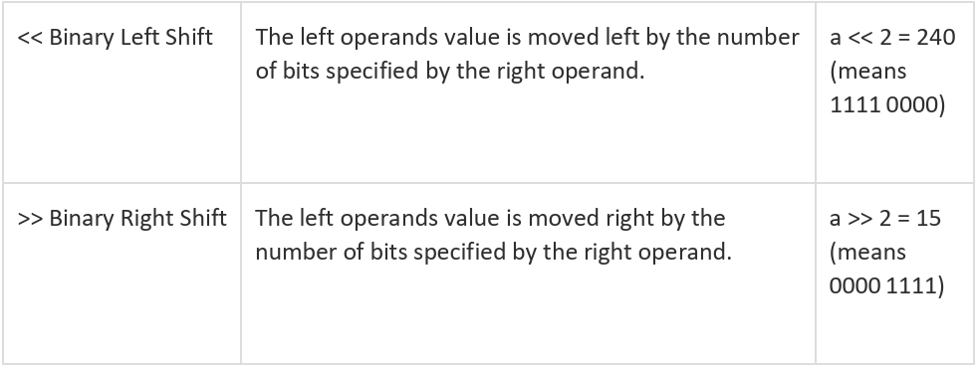

Python Logical Operators
There are following logical operators supported by Python language. Assume variable a holds 10 and variable b holds 20 then
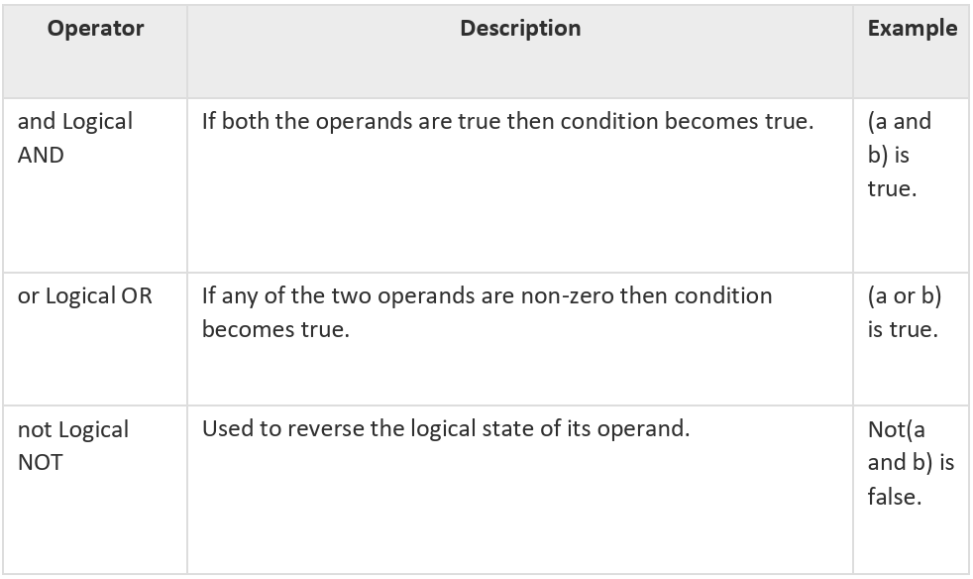

Python Membership Operators
Python’s membership operators test for membership in a sequence, such as strings, lists, or tuples. There are two membership operators as explained below –
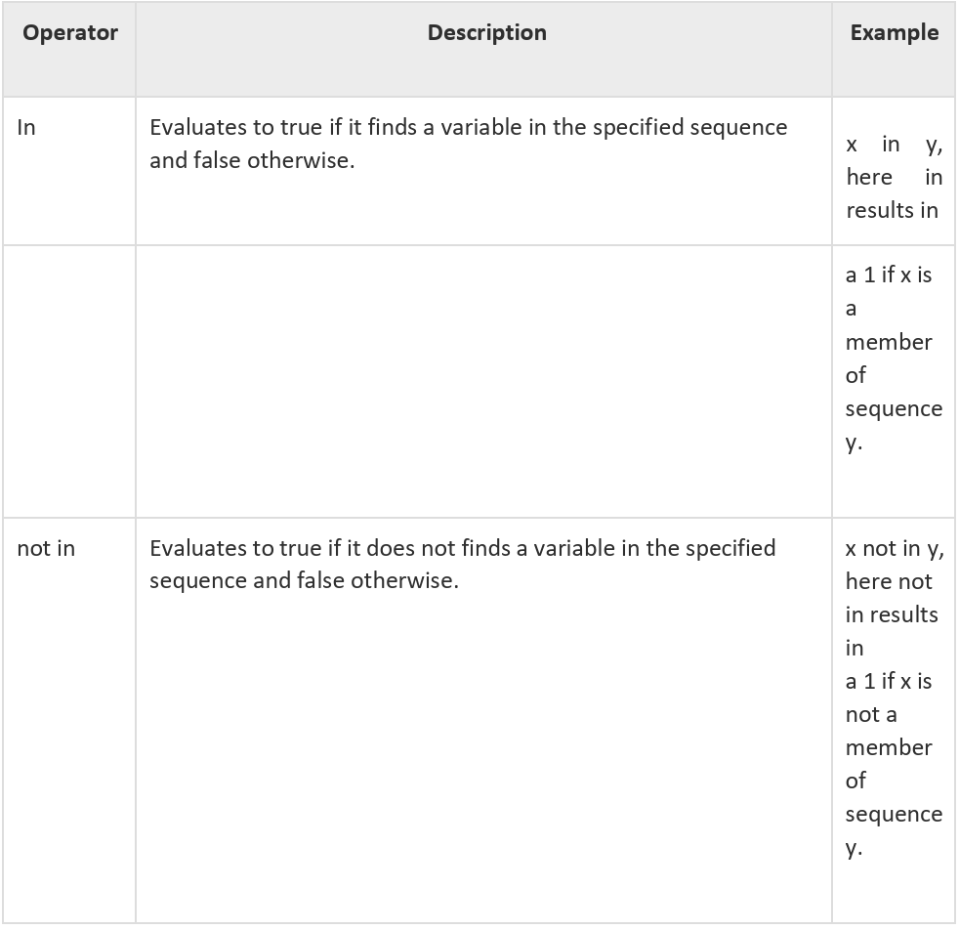

Python Identity Operators
Identity operators compare the memory locations of two objects. There are two Identity operators explained below –
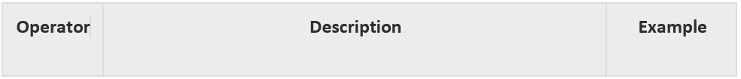
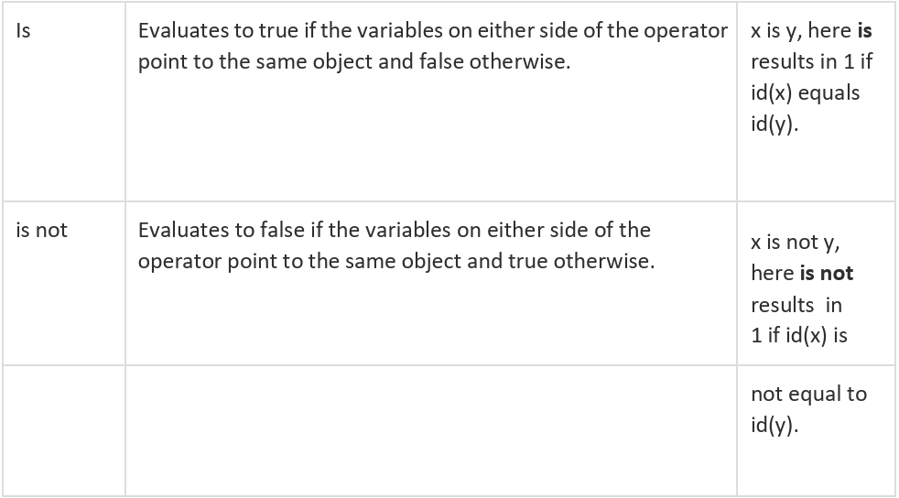

Python Operators Precedence
The following table lists all operators from highest precedence to lowest.
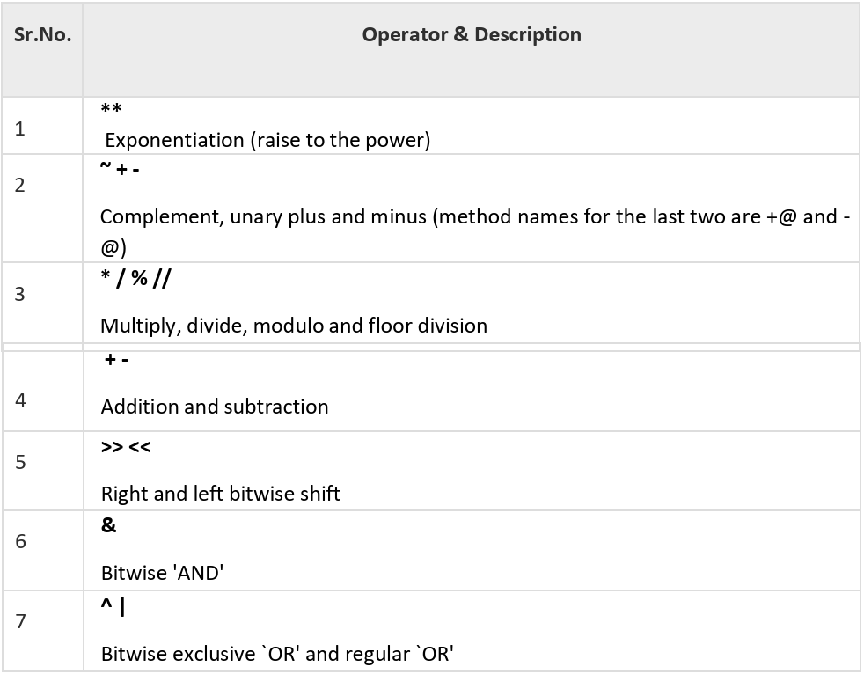
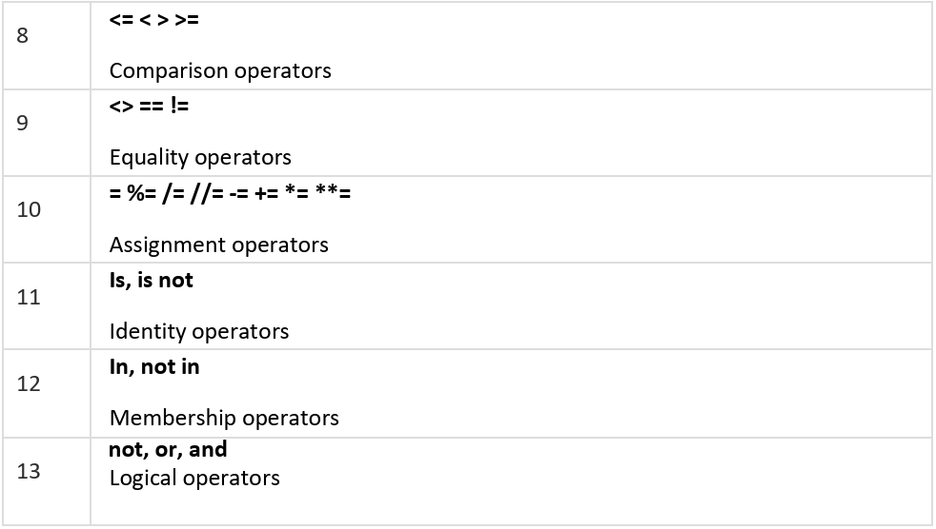

Lab Tasks
Task1:
If the Cost Price is 25% of Selling Price, then find Profit Percentage?
Note: Take a supposed value of Selling Price.
Task2:
Now take the Selling Price as input and recode task1.
Task3:
Write a program that takes two numbers as input from the user and performs all arithmetic operations (+, -, *, /, %, //, **) on them.
Hint: Use int(input(...)) to get integer inputs.
Task4:
Write a program to compare two numbers entered by the user using all comparison operators (==, !=, >, <, >=, <=) and print the Boolean results.
Task5:
Write a script that demonstrates the use of compound assignment operators (e.g., +=, -=, *=) by initializing a variable and then updating its value using these operators.
Task6:
Write a program that takes two boolean inputs (or uses boolean expressions) and demonstrates the and, or, and not logical operators.
Task7:
Write a program to calculate the area of a circle. Prompt the user for the radius and use the formula Area = pi * radius**2.
Task8:
Write a function in Python that accepts one numeric parameter. This parameter will be the measure of an angle in radians. The function should convert the radians into degrees and then return that value.
Task9:
Write a function in Python that accepts a decimal number and returns the equivalent binary number. To make this simple, the decimal number will always be less than 1,024, so the binary number returned will always be less than ten digits long.

